**Sustainable Christmas**

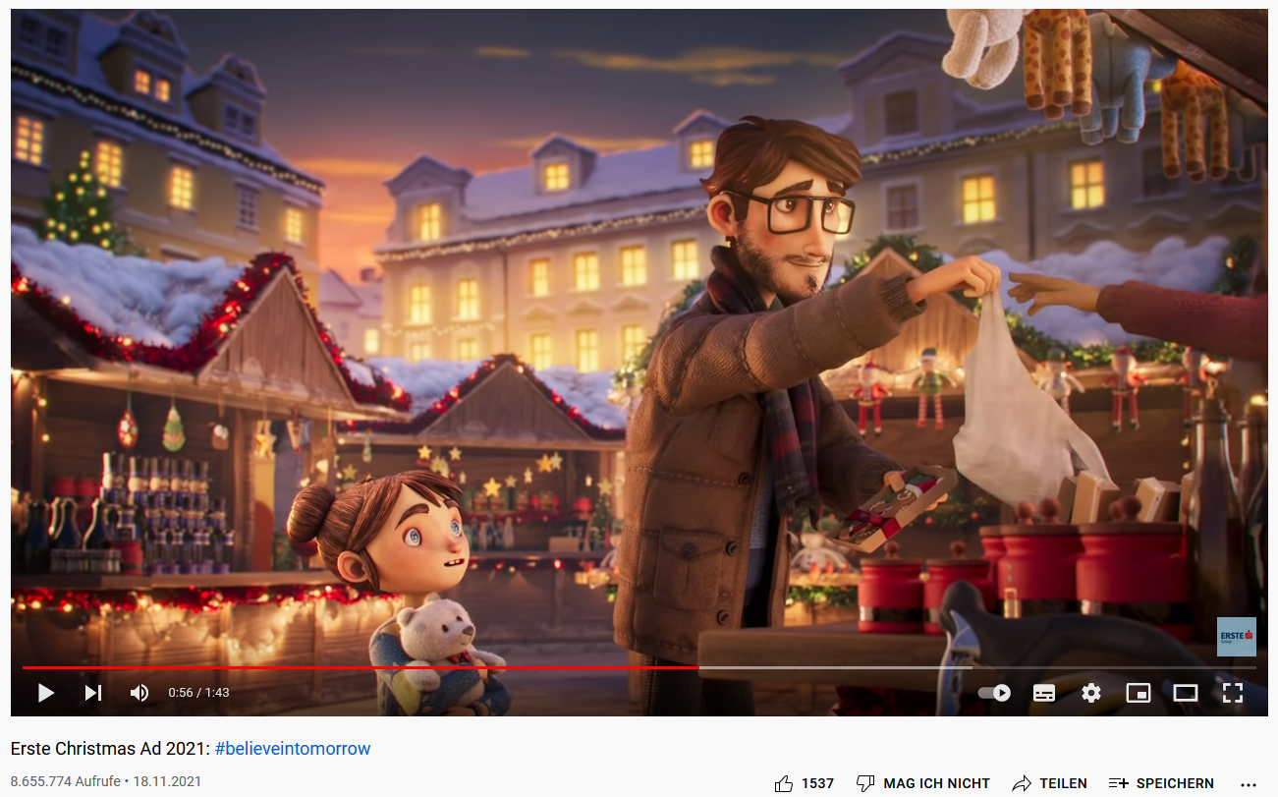

<https://www.youtube.com/watch?v=VWJ-owque-Y>

1. Pre-watching task: Based on the still image what could the short Christmas advertisement be about?

2. While-watching task: **Take notes** on the sustainable actions that the father is doing.

3. Post-watching task: How could you celebrate a more sustainable Christmas? **Discuss** ideas with your partner and write them down.

